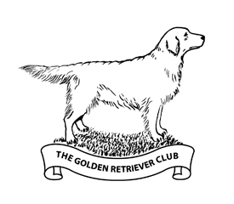

THE GOLDEN RETRIEVER CLUB
NOVICE DOG/NOVICE HANDLER, PUPPY, SPECIAL PUPPY, NOVICE, OPEN & VETERAN WORKING TESTS
Sunday April 26th 2026
Windsor Great Park, Windsor SL4 2HR
By kind permission of His Majesty the King and the Crown Estate Commissioners and Head Keeper Mr Peter Clayton

Judges: Robert Worrall (A), Chris Marshall (B), Jane Manley (NP) and Keith Manley (NP)
Entry Fees: Members £15 Non-Members Entries: £20
Entries: Via FTMS (preference) or exceptionally email: debbiemorgan_1@hotmail.com
Entries Close: April 15th 2026

Meet: 09.00am to start sharp at 9.30am for ND/NH, Puppy, Special Puppy, Novice and Veteran
Open will NOT start before 1pm

- Late entries will be accepted at discretion of Working Test Secretary. These will need to be paper entries on the day of the test. The entry fee will be double, cash only
- All tests whether Classified or Unclassified will be run in accordance with the Kennel Club Rules and Regulations. Rosettes / awards given up to 4th place, subject to entry numbers
- Please do not arrive before 08.30 am
- Please bring cash for our raffle, refreshments and GRC designed unique Vetbed only available through the club. 1m x1.5m £35:00 Vet Bed (Golden Retriever) £35 + Postage | The Golden Retriever Club UK | GRC BACS payment welcome
- We would very much appreciate the donation of any prizes
- Vet on Call: TBC on the day

In the event of any queries please contact: Debbie Morgan, Working Test Secretary
Tel: 07802 940931 Email: debbiemorgan_1@hotmail.com

